LED Interfacing Using 8051

Aim:
To interface an LED with the 8051 microcontroller and control its operation.

Apparatus Required:
1.Laptop with Keil uVision software
2.Proteus Design Suite

Circuit Diagram Setup in Proteus:
- Open Proteus and create a new project.
- Add the following components from the library:
8051 Microcontroller (AT89C51)
LED
Resistor (330Ω)
Ground (GND) connection
- Connect the LED's anode to P1.0 of the microcontroller through a 330Ω resistor.
- Connect the cathode of the LED to GND.
- Save the design and proceed to programming in Keil.

Algorithm:
- Configure P1.0 as an output port.
- Set P1.0 HIGH to turn ON the LED.
- Introduce a delay.
- Set P1.0 LOW to turn OFF the LED.
- Introduce a delay.
- Repeat the process continuously.

Program:

Program (Keil - 8051 Assembly)

; led_blink.asm - Blink LED on AT89C51 P1.0
; Assemble with Keil for AT89C51, produce HEX for Proteus simulation.

ORG 0000H ; Reset vector

START: MOV P1, #0FFH ; Release Port1 (pull-ups) - make sure pins are high by default
CLR A
MAIN_LOOP: SETB P1.0 ; Turn ON LED (assuming LED anode -> P1.0, cathode -> GND via resistor)
ACALL DELAY ; Call delay
CLR P1.0 ; Turn OFF LED
ACALL DELAY ; Call delay
SJMP MAIN_LOOP ; Repeat forever

; -----------------------
; DELAY subroutine
; Nested loops using R7 (outer) and R6 (inner)
; Adjust values for longer/shorter delays
; -----------------------
DELAY: MOV R7, #0FFH ; Outer loop count (255)
DELAY_INNER: MOV R6, #0FFH ; Inner loop count (255)
DELAY_LOOP1: DJNZ R6, DELAY_LOOP1
DJNZ R7, DELAY_INNER
RET

END

Output:
KEIL OUTPUT:

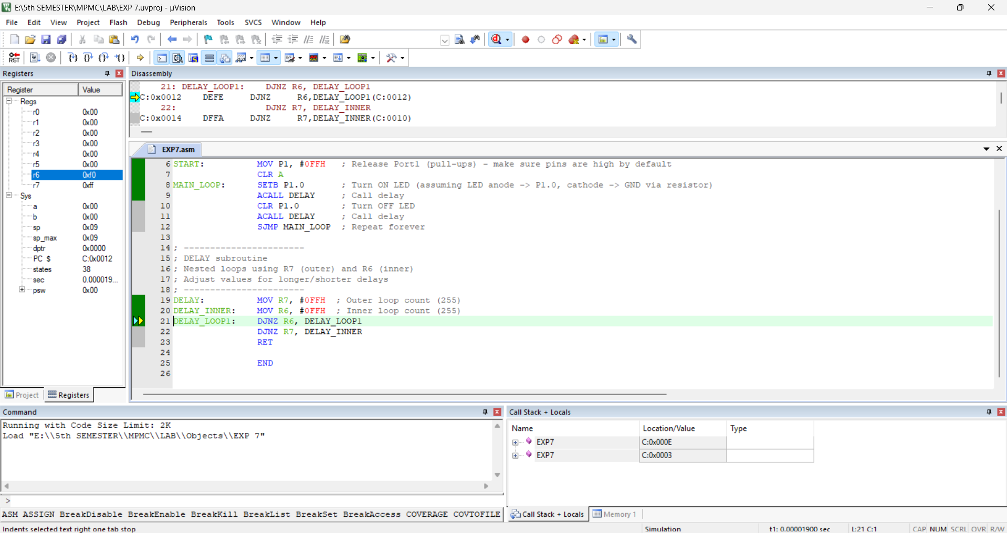

PROTEUS OUTPUT:

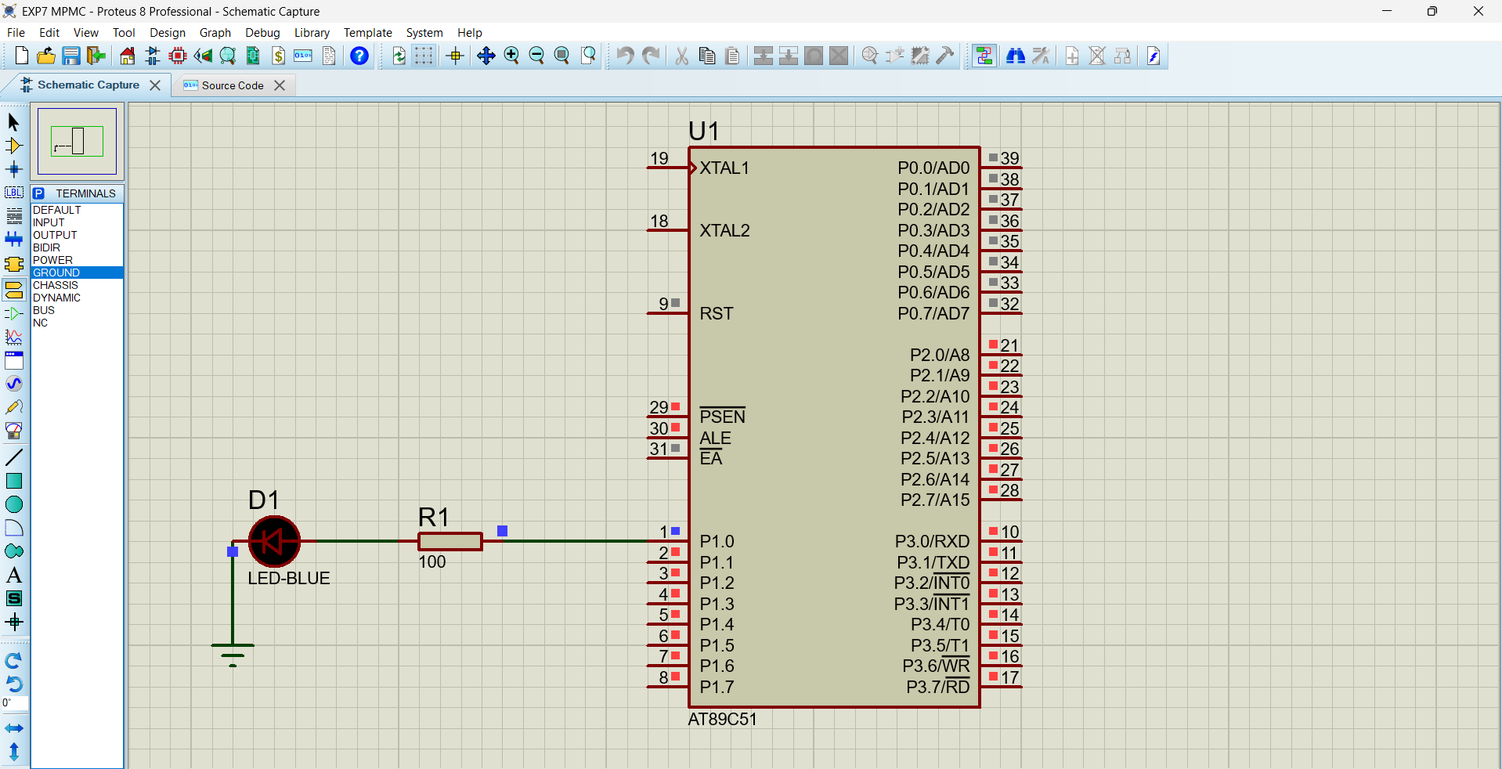

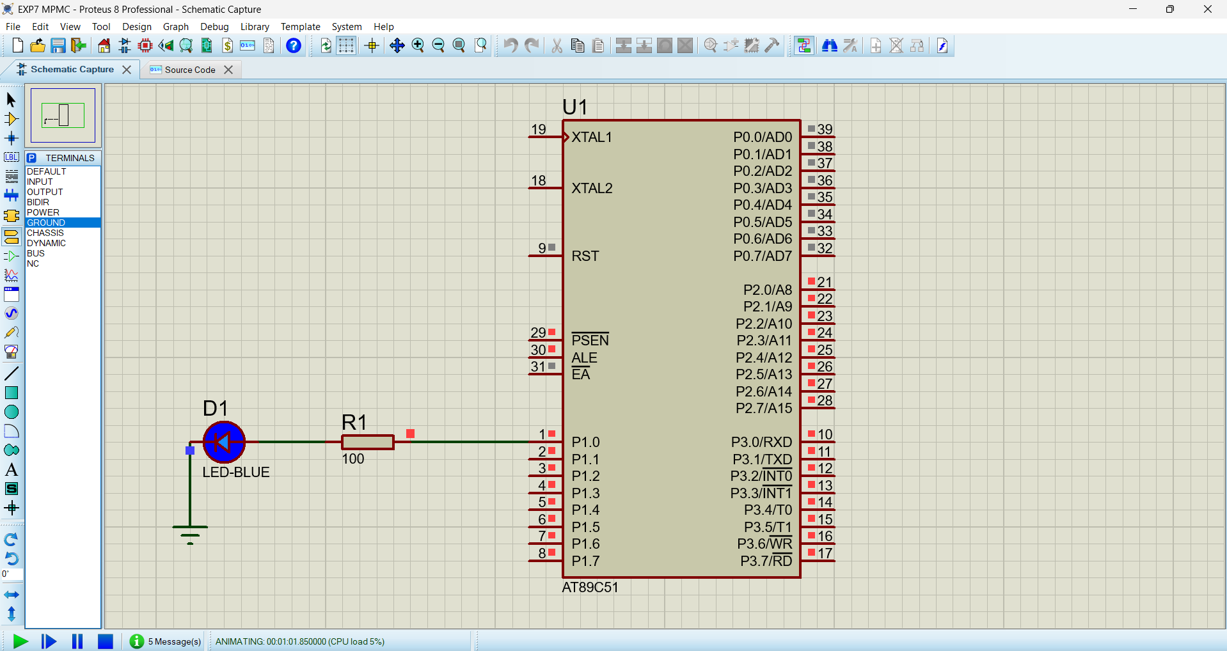

Result:
The LED interfacing with the 8051 microcontroller has been successfully implemented and simulated using Keil and Proteus.

